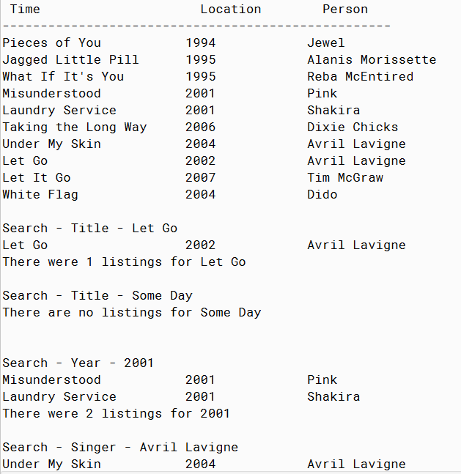

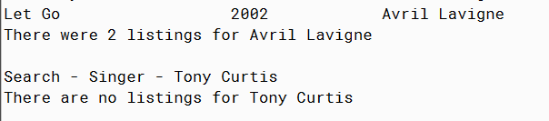

PMR: This project was easy because it was very similar to all of the projects in the last module. I liked this project because I am a big music lover so it was easy to do. I look forward to more projects like this

/\*\*

\* Music interface

\*

\*

\* author Anika Jallipalli

\*

\*/

public class Music

{

// instance variables

private String title;

private int year;

private String singer;

/\*\*

\* Constructor for objects of class Music

\*/

public Music(String t, int l, String p)

{

// initialise instance variables

title = t;

year = l;

singer = p;

}

public void settitle(String t)

{

title = t;

}

public String gettitle()

{

return title;

}

public void setyear(int l)

{

year = l;

}

public int getyear()

{

return year;

}

public void setsinger(String p)

{

singer = p;

}

public String getsinger()

{

return singer;

}

public String toString()

{

return String.format("%-18s", title) + "\t" + String.format("%-10s", year) +

"\t" + String.format("%-15s", singer);

}

}

/\*\*

\* run the program

\*

\*

\* author Anika Jallipalli

\*

\*/

public class TestMusic {

public static void main(String[] args)

{

Music[] myMusic = new Music[10];

myMusic[0] = new Music("Pieces of You",1994, "Jewel");

myMusic[1] = new Music("Jagged Little Pill",1995,"Alanis Morissette");

myMusic[2] = new Music("What If It's You", 1995,"Reba McEntired");

myMusic[3] = new Music("Misunderstood",2001,"Pink");

myMusic[4] = new Music("Laundry Service",2001,"Shakira");

myMusic[5] = new Music("Taking the Long Way",2006,"Dixie Chicks");

myMusic[6] = new Music("Under My Skin",2004,"Avril Lavigne");

myMusic[7] = new Music("Let Go",2002,"Avril Lavigne");

myMusic[8] = new Music("Let It Go",2007,"Tim McGraw");

myMusic[9] = new Music("White Flag",2004,"Dido");

printmyMusic(myMusic);

System.out.println();

System.out.println("Search - Title - Let Go");

findTitle(myMusic, "Let Go");

System.out.println();

System.out.println("Search - Title - Some Day");

findTitle(myMusic, "Some Day");

System.out.println();

System.out.println("Search - Year - 2001");

findYear(myMusic, 2001);

System.out.println();

System.out.println("Search - Singer - Avril Lavigne");

findSinger(myMusic, "Avril Lavigne");

System.out.println();

System.out.println("Search - Singer - Tony Curtis");

findSinger(myMusic, "Tony Curtis");

}

public static void printmyMusic(Music[] r)

{

System.out.println("Time Location Person");

System.out.println("---------------------------------------------------");

for(int i = 0; i < r.length; i++)

{

if(r[i] != null)

{

System.out.println(r[i]);

}

}

}

public static void findSinger(Music[] r, String toFind)

{

int found = 0;

for(int i = 0; i < r.length; i++)

{

if (r[i].getsinger() != null)

{

if (r[i].getsinger().compareTo(toFind) == 0)

{

System.out.println(r[i]);

found++;

}

}

}

if (found == 0)

{ // we have not found the location

System.out.println("There are no listings for " + toFind);

System.out.println();

}

else

{

System.out.print("There were " + found + " listings for " + toFind);

System.out.println();

}

}

public static void findTitle(Music[] r, String toFind)

{

int found = 0;

for(int i = 0; i < r.length; i++)

{

if (r[i].gettitle() != null && toFind != null) //java.lang.NullPointerException occurs here

{

if (r[i].gettitle().compareTo(toFind) == 0)

{

System.out.println(r[i]);

found++;

}

}

}

if (found == 0)

{ // we have not found the location

System.out.println("There are no listings for " + toFind);

System.out.println();

}

else

{

System.out.print("There were " + found + " listings for " + toFind);

System.out.println();

}

}

public static void findYear(Music[] r, int toFind)

{

int found = 0;

for(int i = 0; i < r.length; i++)

{

if (r[i].getyear() == toFind)

{

System.out.println(r[i]);

found++;

}

}

if (found == 0)

{ // we have not found the location

System.out.println("There are no listings for " + toFind);

System.out.println();

}

else

{

System.out.print("There were " + found + " listings for " + toFind);

System.out.println();

}

}

}